**1. ten deciles of momentum**

[table]

|  |  |  |  |  |  |  |  |  |  |  |
| --- | --- | --- | --- | --- | --- | --- | --- | --- | --- | --- |
| Decile | Decile 1 | Decile 2 | Decile 3 | Decile 4 | Decile 5 | Decile 6 | Decile 7 | Decile 8 | Decile 9 | Decile 10 |
| mean | 0.111 | 0.112 | 0.113 | 0.115 | 0.119 | 0.123 | 0.126 | 0.132 | 0.140 | 0.145 |
| sd | 0.172 | 0.171 | 0.169 | 0.170 | 0.173 | 0.177 | 0.183 | 0.193 | 0.219 | 0.263 |
| Sharpe | 0.361 | 0.370 | 0.383 | 0.389 | 0.406 | 0.421 | 0.424 | 0.435 | 0.418 | 0.366 |

[plot] 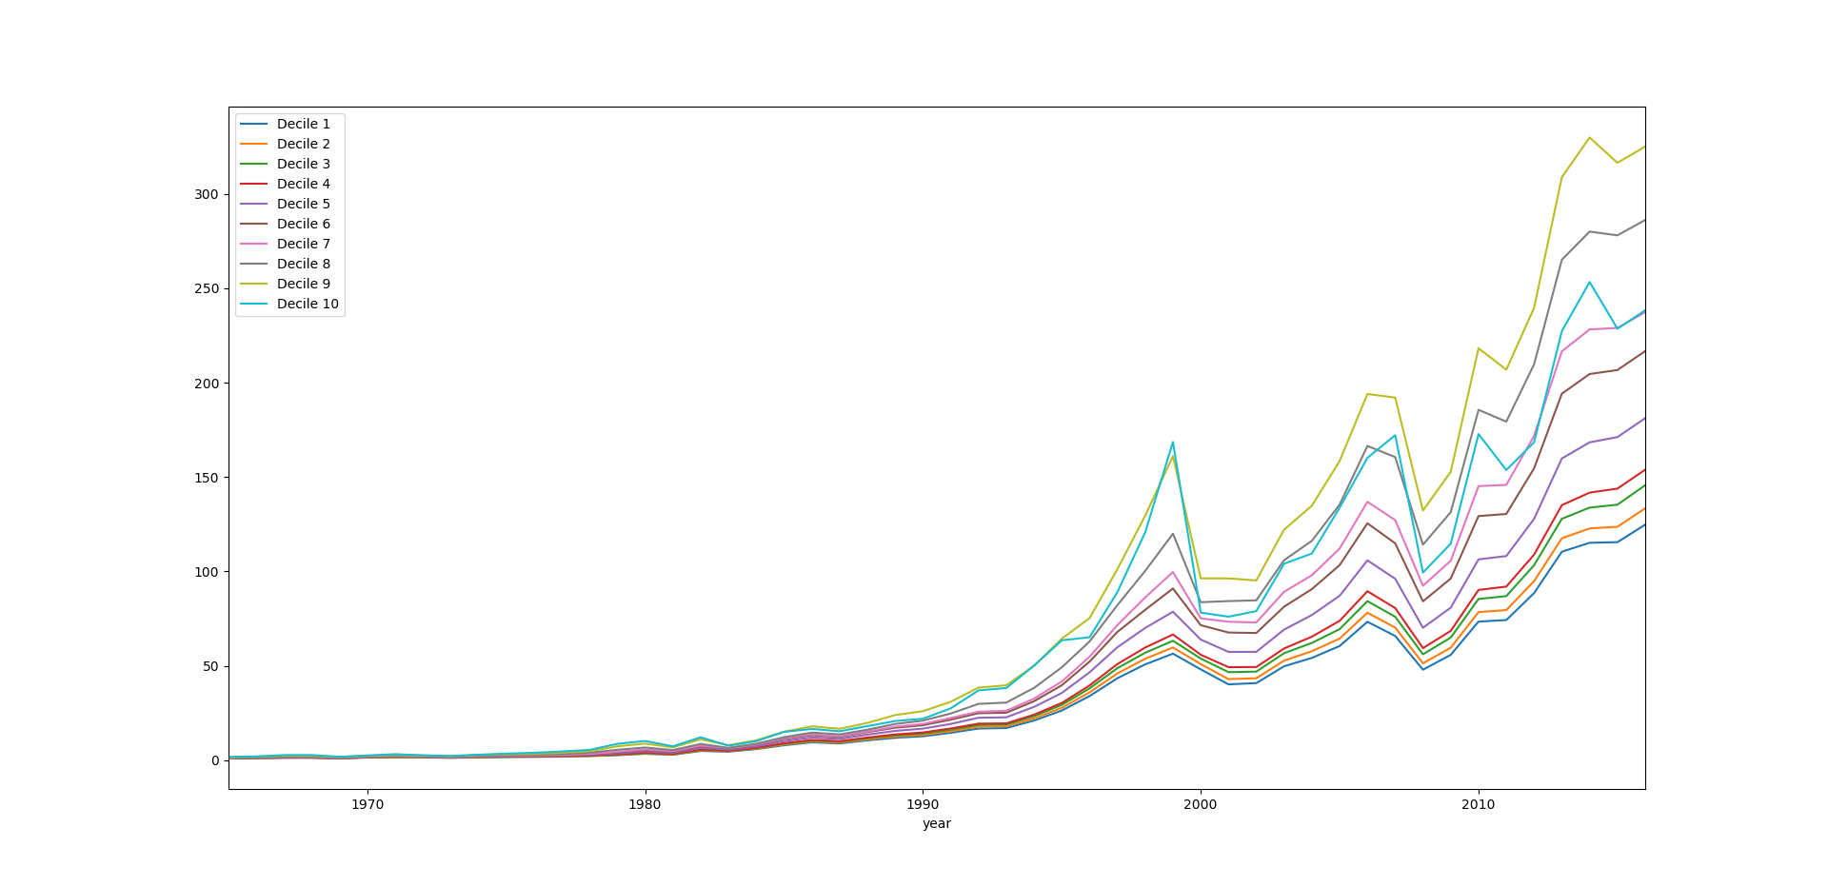

**2. seven momentum indicators**

**2.1 decile 10 + transaction cost at a glance**

Raw return and Sharpe

[table]

|  |  |  |  |  |  |  |  |
| --- | --- | --- | --- | --- | --- | --- | --- |
| raw return | prev_1_1 | prev_1_12 | prev_1_24 | prev_1_36 | prev_2_12 | prev_2_24 | prev_2_36 |
| mean | 0.125 | 0.152 | 0.127 | 0.131 | 0.145 | 0.124 | 0.130 |
| sd | 0.276 | 0.267 | 0.276 | 0.271 | 0.263 | 0.279 | 0.273 |
| Sharpe | 0.278 | 0.387 | 0.284 | 0.304 | 0.366 | 0.271 | 0.298 |

Net return and Sharpe

[table]

|  |  |  |  |  |  |  |  |
| --- | --- | --- | --- | --- | --- | --- | --- |
| net return | prev_1_1 | prev_1_12 | prev_1_24 | prev_1_36 | prev_2_12 | prev_2_24 | prev_2_36 |
| mean | 0.122 | 0.149 | 0.125 | 0.129 | 0.142 | 0.122 | 0.128 |
| sd | 0.276 | 0.266 | 0.276 | 0.271 | 0.263 | 0.279 | 0.273 |
| Sharpe | 0.267 | 0.378 | 0.277 | 0.298 | 0.356 | 0.263 | 0.292 |

[plot]

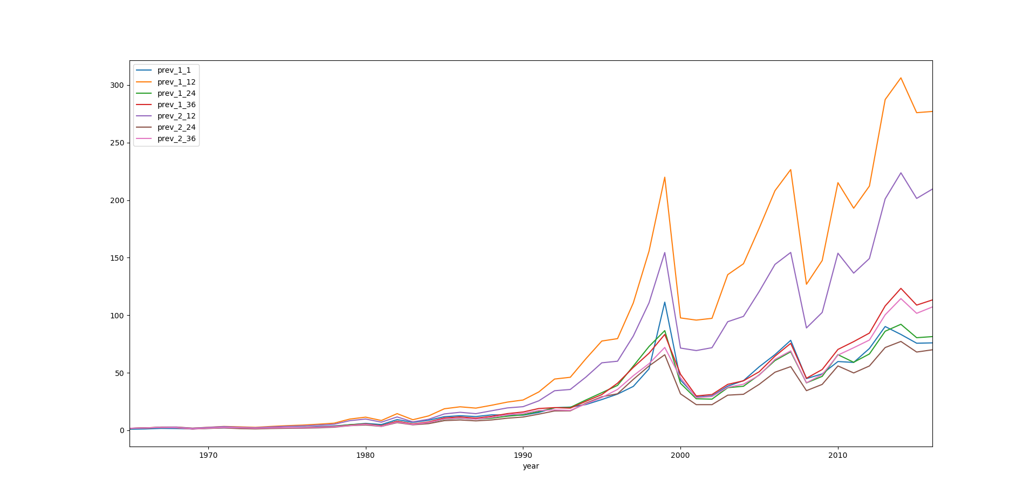

**2.2 decile 20**

[table]

|  |  |  |  |  |  |  |  |
| --- | --- | --- | --- | --- | --- | --- | --- |
| net return | prev_1_1 | prev_1_12 | prev_1_24 | prev_1_36 | prev_2_12 | prev_2_24 | prev_2_36 |
| mean | 0.113 | 0.137 | 0.128 | 0.122 | 0.138 | 0.128 | 0.125 |
| sd | 0.214 | 0.219 | 0.223 | 0.219 | 0.219 | 0.228 | 0.223 |
| Sharpe | 0.301 | 0.404 | 0.357 | 0.337 | 0.408 | 0.350 | 0.344 |

[plot]

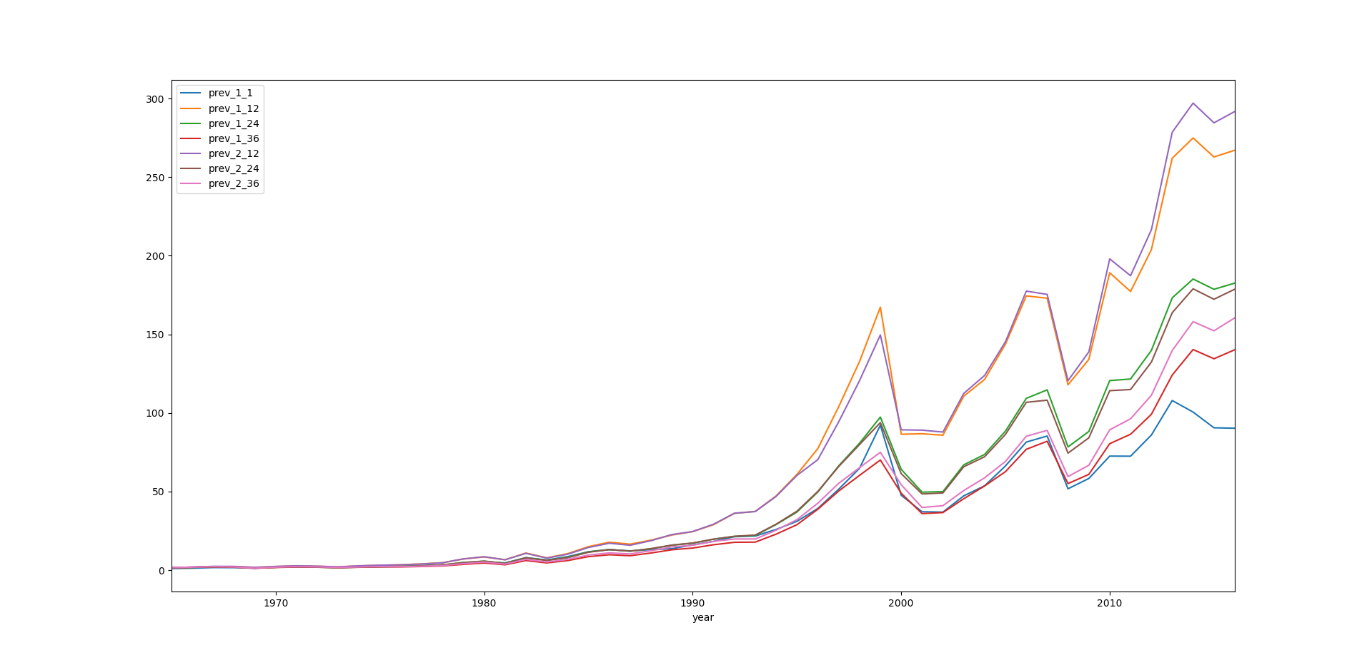

**3. transaction cost minimization**

[plot]

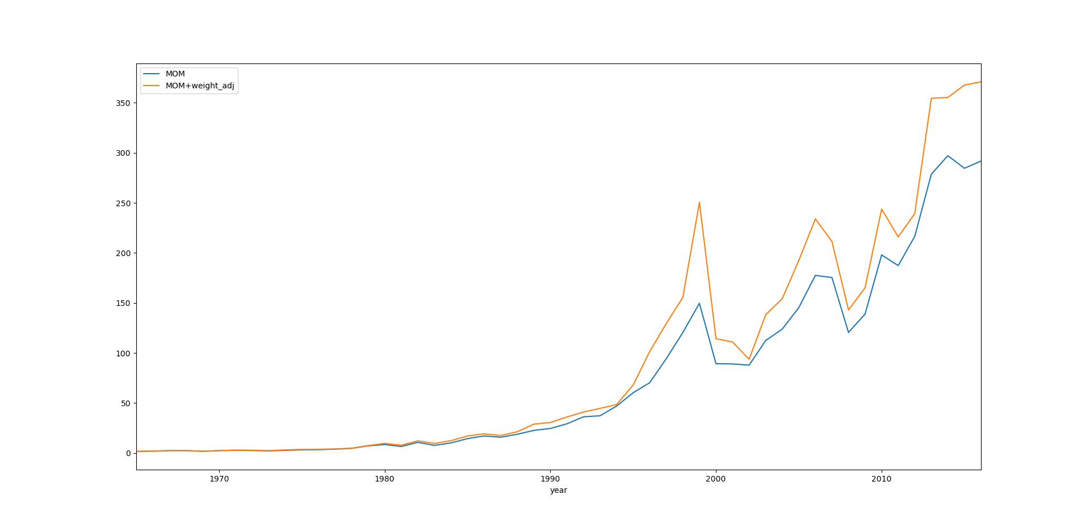

**4. momentum + value + size**

[plot]

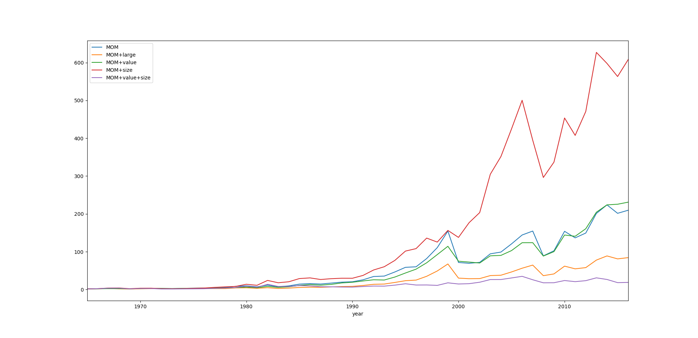

4.1 number of stock in portfolio

[bar plot]

